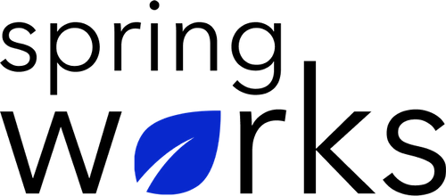
Free Template – Employee Motivation Survey
Use this survey to understand if the employees are motivated or not.

An employee motivation survey allows you to identify key motivators in your organization as well as detect what could increase motivation. Copy this template to your Google Drive and customize it for your organization.

Communication (to be added as review instructions):

Your responses to this survey are anonymous. The leaders are committed to analyzing your results and taking action. Please answer this quick survey by <HOUR OF THE DAY> on <DATE>.

Thank you for your time. Your responses will help our organization become a better place to work. If you have any questions about the survey, please contact [insert name of contact person].

Demographic Information:

The following information is requested so that meaningful analysis and comparisons of group results can be made. Please check the circle corresponding to your answer.

Q: Your Gender:

- Male
- Female

Q: Your Department:

- Marketing
- Operations
- Tech
- Accounting
- HR
Q: Company Service:

- Under 1 Year
- 1-2 Year
- 3-5 Year
- 6-10 Year
- 10-15 Year

Employee Motivation Questionnaire

To answer clearly what you think or feel about each item, please follow these steps:

- Read each item fully before you start to mark your answer.
- Pick the one answer which most nearly says what you think or how you feel.
- While completing the questions, be sure to read the special instructions which are included.

Choose the most appropriate answer:

Q: How stimulating and engaging is your work?

😞 😏 😐 😊 😀

Q: How motivated are you at work?

😞 😏 😐 😊 😀

Q: I feel inspired to do my best at work every day:

- Strongly agree
- Agree
- Neutral
- Disagree
- Strongly disagree

Q: I am motivated to go the extra mile at work:

- Strongly agree
- Agree
- Neutral
- Disagree
- Strongly disagree

Q: My job is challenging and exciting:

- Strongly agree
- Agree
- Neutral
- Disagree
- Strongly disagree

Q: My job allows me to grow and develop new skills:

- Strongly agree
- Agree
- Neutral
- Disagree
- Strongly disagree

Q: I feel I am contributing to the overall goals of my organization:

- Strongly agree
- Agree
- Neutral
- Disagree
- Strongly disagree

Q: A manager has shown sincere interest in my career goals:

- Strongly agree
- Agree
- Neutral
- Disagree
- Strongly disagree

Q: I feel that my work is seen and appreciated within my organization:

- Strongly agree
- Agree
- Neutral
- Disagree
- Strongly disagree

Q: The recognition I receive from my direct manager motivates me to do my best:

- Strongly agree
- Agree
- Neutral
- Disagree
- Strongly disagree

Q: How focused are you on your job duties when at work?

😞 😏 😐 😊 😀

Q: How excited to go to work are you usually?

😞 😏 😐 😊 😀

Q: I look forward to going to work on Monday:

- Strongly agree
- Agree
- Neutral
- Disagree
- Strongly disagree

Q: I am motivated by my organization's vision:

- Strongly agree
- Agree
- Neutral
- Disagree
- Strongly disagree

Q: What is your number one motivator at work?

Q: What could your organization do to increase your job motivation?

Q: How likely are you to recommend your organization as a place to work?

0 | 1 | 2 | 3 | 4 | 5 | 6 | 7 | 8 | 9 | 10

Thanks for your response!

